Forget Me Not – Power Timer

Description:
For any of us that have left a plugin device on (heater, lamp…) and then forgot to turn it off, this is for you. It’s an easy to use timer. With a push of a button, one can power devices up to 1875 watts. The timer has a 4 foot cord, 2 outlets, a main power switch and 4 illuminated pushbuttons. Each pushbutton enables power to both outlets. 3 pushbuttons enable power for a set amount of time and one keeps the power on.
No WiFi, no programming, it doesn’t even matter if your cell phone is dead; it just works. Push a button, it lights up and the outlets have power. Once the Power Timer times out, the pushbutton light goes out and the outlets are disconnected from power.
The main power switch lights up when on. While this powers the Power Timer, the outlets will not have power unless a pushbutton is illuminated (after being pressed).

Details:
Power Timer uses NE556N (dual 555) timer ICs and CD4082BE dual 4 input AND gates to control operation. Three NE556N ICs control the duration of how long the unit is enabling power and the fourth simply enables power. When a pushbutton is pressed, the CD4082BE ICs reset the NE556N ICs not connected to that pushbutton. So, when a pushbutton is pressed, irrelevant of what function was previously running, the full duration of that new function will run.
Three of the timers are configured as monostable multivibrators. In other words, they run for a set amount of time then shut off. The amount of time is governed by the following equation: t (seconds) = 1.1R(ohms)C(farads). So, a 1M resistor and a 270uF cap would produce an on time of 5 minutes. Well nice in theory but, in reality the results are not exact. First off, the cap is ±20% and its capacitance is greater than the recommended value for a 555 type timer. With those components I measured 6¼ minutes. Then I put a 2M in parallel with the 1M and measured 4¼ minutes. Your results may vary so keep that in mind.
That last timer is configured as a set/reset flip flop.
Testing was done with all the PCB components populated except the AC/DC converter and the pushbutton switches. An external power supply was used to supply a nice, safe 12V. The pushbutton switches are soldered in as one of the very, very last assembly steps. This is very important to note because Power Timer PCB can NOT be assembled into the chassis with the pushbutton switches soldered to the board! Also note the pushbutton switches are to be soldered to the back side of the PCB.
The 3D printed part that holds the pushbutton switches (PushButHold) also holds a heat insert for a 4-40 screw. The heat insert is melted into the part. One can use a soldering iron tip to gently melt it in. See Figure 5 Pushbutton Assembly

Pictures:
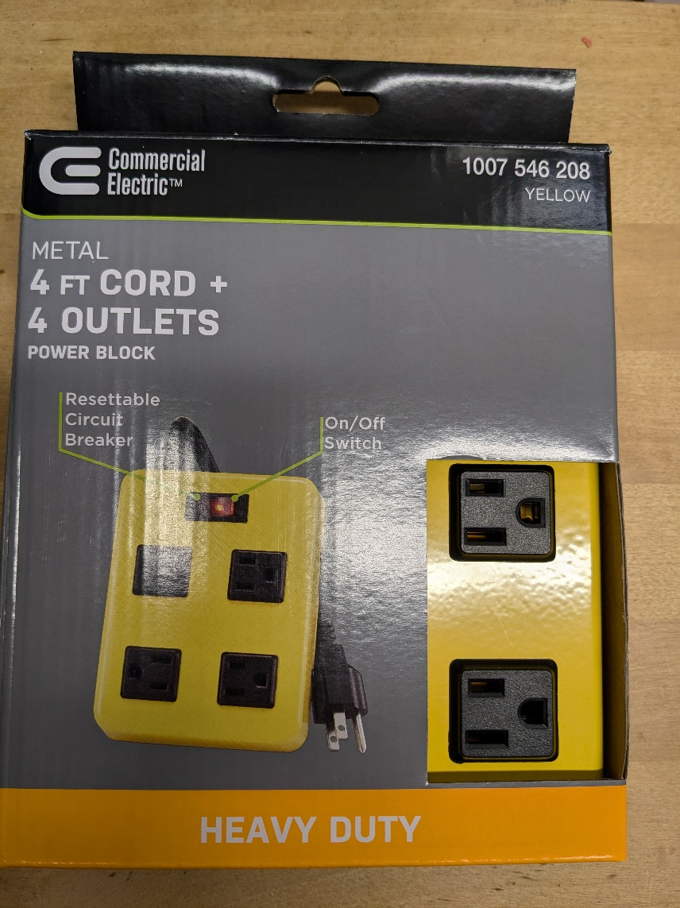
Figure 1 Power Block from Home Depot
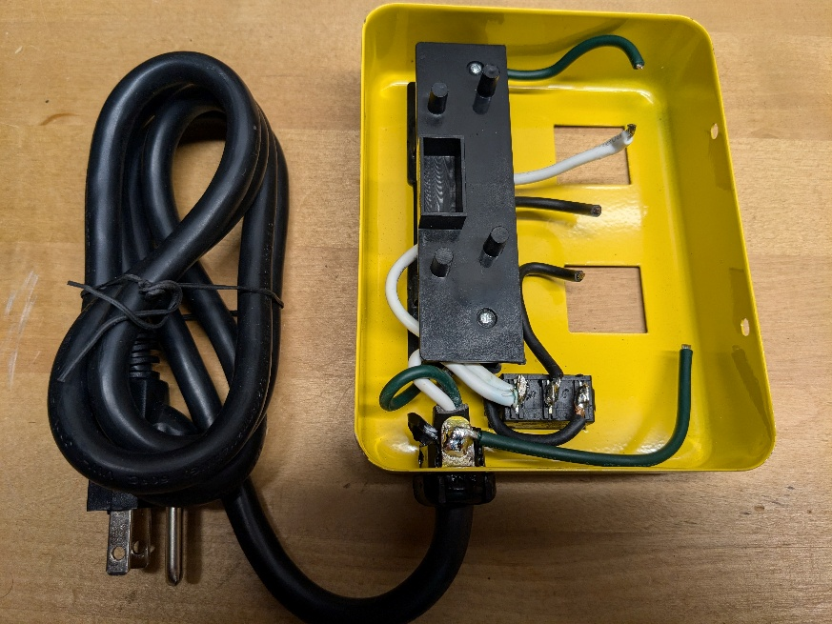
Figure 2 Two Outlets Removed

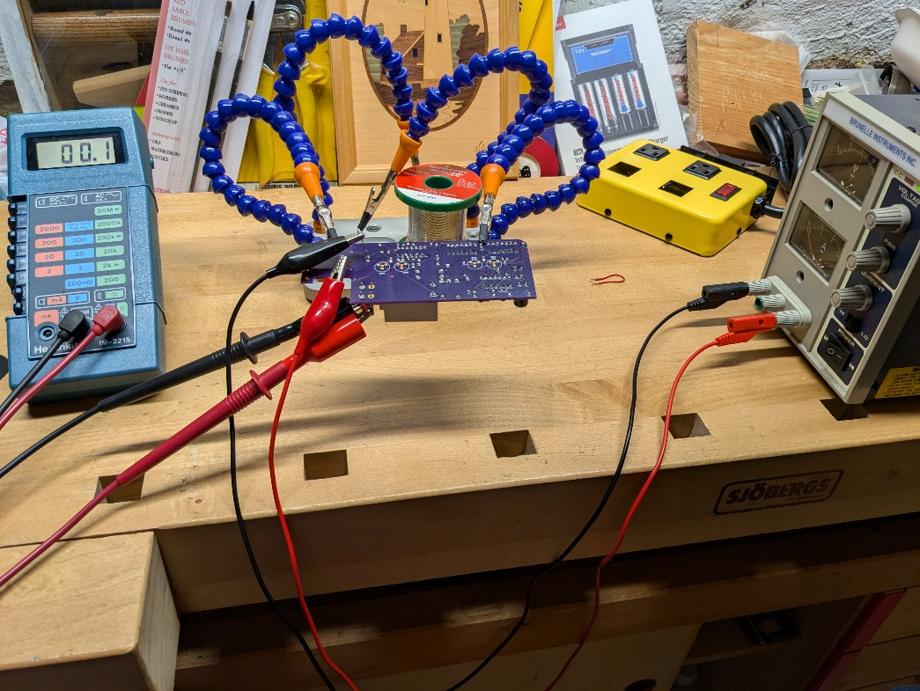
Figure 3 Test Setup using an External Power Supply
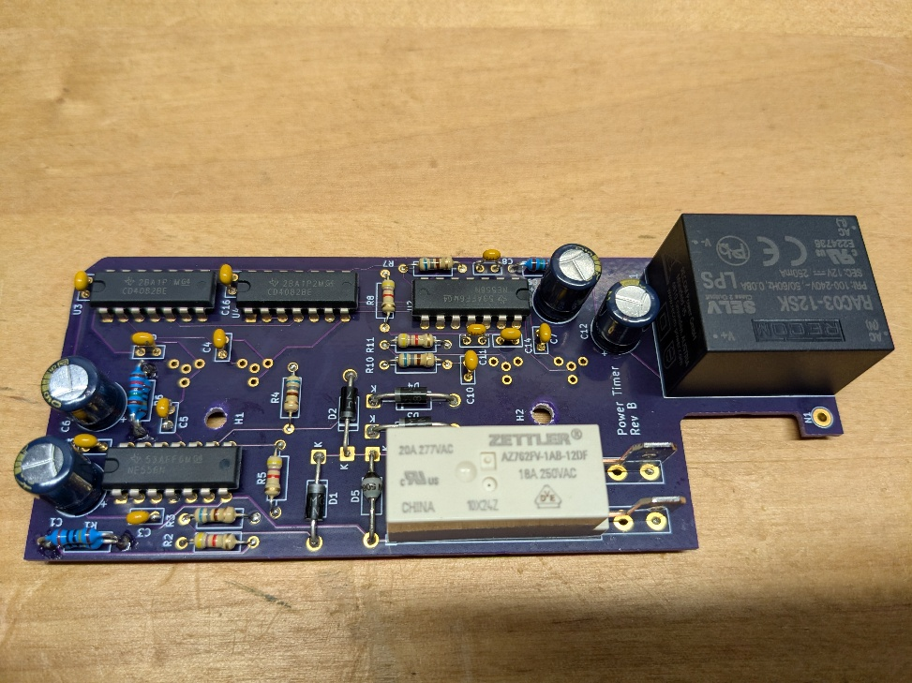
Figure 4 PCB Assembly without Pushbutton Switches
Note the current PCB revision is Rev C. It contains some fixes and minor changes to the Rev B shown in the picture.

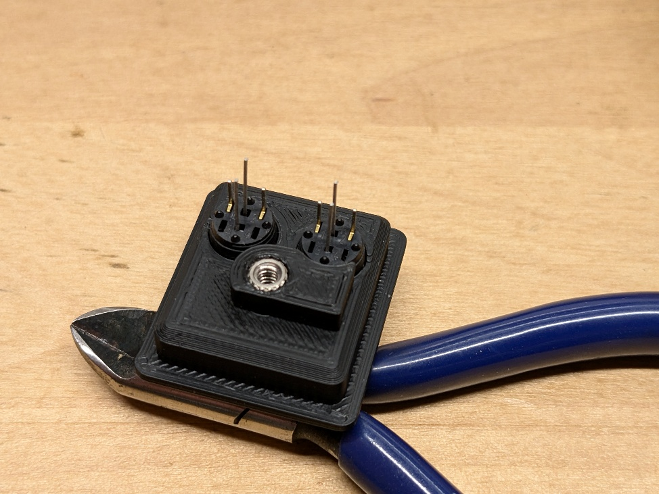
Figure 5 Pushbutton Assembly
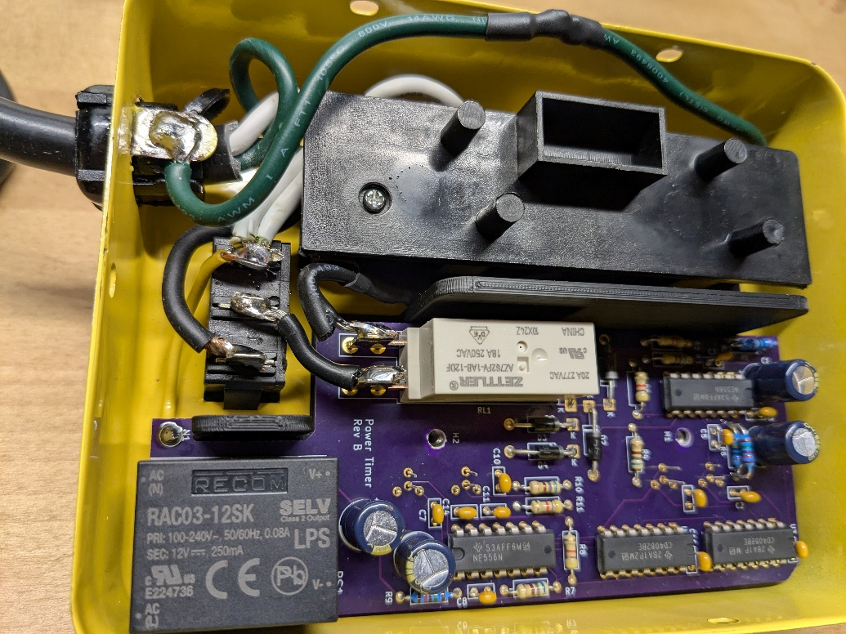
Figure 6 Fully Wired Chassis

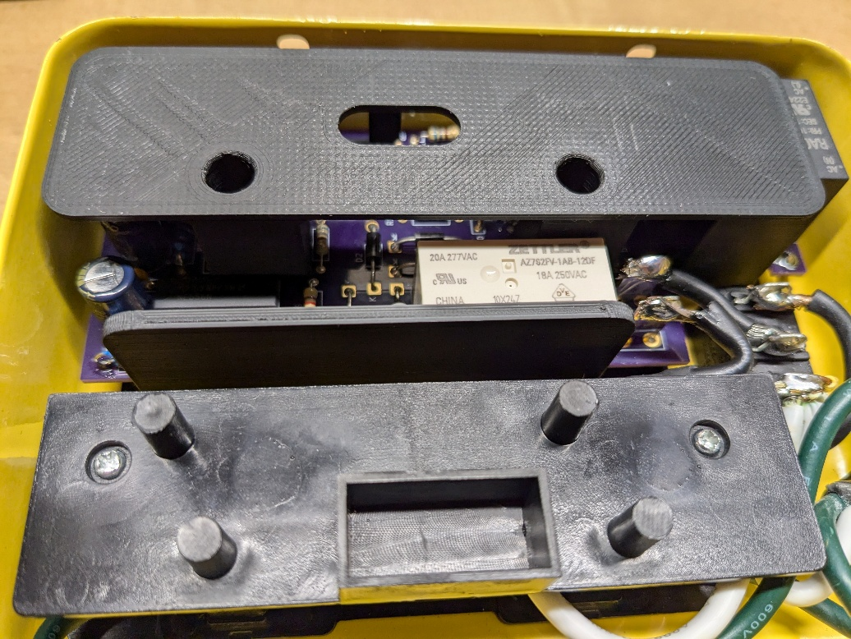
Figure 7 Fully Assembled Chassis without Cover
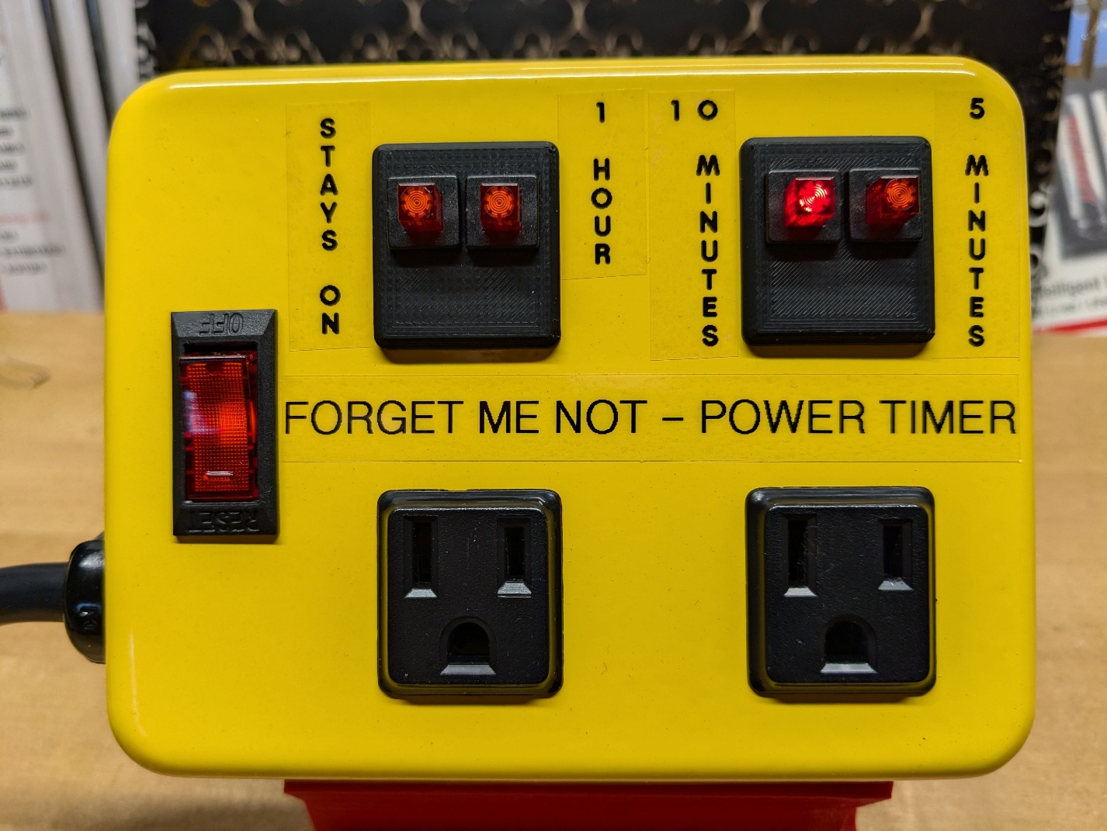
Figure 8 Finished Unit with 10 Minute Timer Running

